**Task:** Create your Website folder structure and the first two pages. Follow all steps in the instructions below.

1. Download the Visual Studio Code editor from <https://visualstudio.microsoft.com/>

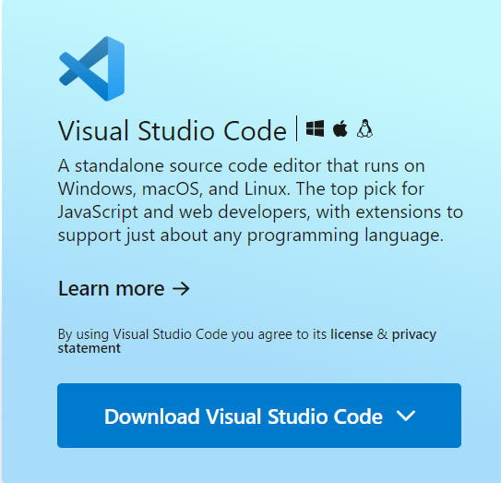

1. Click on the extension icon and add the following extensions:

* HTML CSS Support
* Live Server
* Prettier

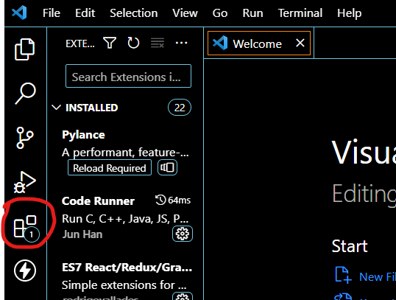

1. Set up your **folder structure in VS Code,** as demonstrated in the lecture section with the VS Code demo - including required naming conventions and all required files - as shown in the screenshot below:

**REMINDER:** Click File in the menu, then ‘New File’ to create files in VS Code. Use Explorer and right-click, then select ‘New folder’ to add your images folder.

1. **Open** *index.html* in VS Code and use the keyboard shortcuts provided in the lecture demo to create the HTML skeleton, then save it. Do the same for *about.html*
2. **Review** both examples of a Teaching Portfolio website, then **complete** the evaluation in the table below for one of these.

Example 1: <https://northeastern.digication.com/cassandraburke/About_Me>

Example 2: <https://saracampion.github.io/>

**Evaluation of existing Teaching Portfolio Website Example**

|  |  |  |
| --- | --- | --- |
| *Example No:* | *Describe the users (of the website i.e. the groups of people it is made for)* | *Define the Website goals* |
| Example 1 | 1. other teachers  2. students wanting to learn about their teacher  3. schools or prospective jobs | 1. to talk about herself and her goals as a teacher  2. what she does with children in the classroom and what she teaches  3. |

1. **Save** all image files into the images folder of your website (drag and drop using ‘Explorer’ in VSCode) – these are the ones you created/modified using the section of the lecture focused on “Graphic Design Demos using Canva”
2. Graphic Design for your Website **- Complete** the tables below according to the instructions in provided in italics (you should remove the instruction text and replace with your own work)

Enhanced Profile Photo for your website:

|  |  |  |
| --- | --- | --- |
| **Original photo** | **Edited photo** | **Describe all changes/modifications made to original** |
|  |  | *changed temperature to -13*  *increased brightness to 8*  *cropped image to a square* |

Visual Tiles/Infographics for your website:

|  |  |  |
| --- | --- | --- |
| **Graphic created (you must include two different ones)** | **Name of page created for** | **List the key steps used to make your image** |
|  | *teaching philosophy page* | *a banner with colour images and text to create a banner graphic for my teaching philosophy*  *is a horizontal and rectangular shape*  *brightness is changed to 10 to be able to see more contrast* |
|  | *about me page* | *a banner with color, and images and text*  *is cropped to be more horizontal and rectangular*  *brightness is changed to 18 and darkness is changed to -15 to add some contrast* |

1. **Select** about.html tab in VS Code, change the website name in the header from ‘Document’ to your chosen name, as shown in the lecture demo.
2. Then **add** **the following content** in the body section of your ‘About Me’ (about.html) page:
   1. **Add a Page Heading**  
      ‣ Use a heading tag (e.g. <h1>) with the text: About me
   2. **Style Your Heading Colour**  
      ‣ Use **inline CSS** (e.g. <h1 style="color:blue">) to set the heading to any colour **except black or white**  
      ‣ Use the **Adobe Color Contrast Checker** (<https://color.adobe.com/create/color-contrast-analyzer>) to make sure the colour is readable on a **white background.** Take a **screenshot** of the **‘pass’ result** then **paste it in the box provided below.**
   3. **Add Your Profile Image**  
      ‣ Insert the enhanced profile image you edited earlier  
      ‣ *(Optional)*: Set its width to 250px using HTML
   4. **Add One Graphic from Canva**  
      ‣ Insert at least **one design** (e.g. a visual tile or infographic) that you made in Canva  
      ‣ Add text before and/or after the image to help it make sense on the page
   5. **Write About Yourself**  
      ‣ Include at least **two paragraphs** with key details about you  
      ‣ Use the examples in **Step 5** from earlier as a guide
   6. **Add Text Styling**  
      ‣ Change the **font** on at least one **heading or paragraph**  
      ‣ Use **italic styling** for one heading or paragraph
   7. **Add a Hyperlink**  
      ‣ Insert a link (<a>) to at least one external website that is relevant to your **teaching** or **studies**
   8. **Add Comments in Code**  
      ‣ Use <!-- comment --> to explain each major section of your HTML, as shown in the lecture demo

### 🌟 Optional / Extension Tasks:

1. **Background Colour**  
   ‣ Change the background colour of the page  
   ‣ You must also change the **text colour** in Step 2 to make sure it **passes the Contrast Checker**  
   ‣ Take a screenshot of your ‘pass’ result in **Contrast Checker** and upload it to the space below
2. **Add a List**  
   ‣ Include a list (<ul> or <ol>) about something relevant to you

*HINT:* Remember to keep checking the Live Preview tab as you make changes, to ensure your HTML code is correct as you go along.

|  |
| --- |
| Screenshot/s of Results from the ‘Contrast Checker ‘- Adobe Color Accessibility Tools: |

1. **Submit** your entire website folder as a zip file, including a completed **PDF FILE copy** of this worksheet. File name must be in this format:

**Lastname Firstname – Week01.zip**